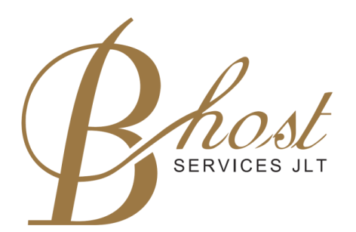

P R E S S R E L E A S E
“Lausanne Executive Education in Gulf Region”

Partnership Agreement between
B.Host Services JLT
and
Lausanne Hospitality Consulting SA

Lausanne, 23rd September 2013
Lausanne Hospitality Consulting SA (LHC), Ecole hôtelière de Lausanne (EHL) subsidiary, and B.Host Services JLT are delighted to announce the signature of a partnership agreement. B.Host Services JLT shall represent LHC in the UAE and in the Gulf area for the promotion of Lausanne Executive Education programmes. Courses are delivered both at EHL in Lausanne and in Dubai. This agreement was signed at Ecole hôtelière de Lausanne by Mr Yateendra Sinh, CEO Lausanne Hospitality Consulting SA and Mr Fathi Nour, CEO B.Host Services JLT.
“Lausanne Executive Education in Gulf Region”
LHC has designed a variety of hospitality management programmes to keep industry organizations competitive. These programmes are targeted at progressive middle to senior executives and tackle priority issues in the business environment through the following streams: Operations; Finance & Marketing; Strategy & Business Development and Leadership & Management.
B.Host Services JLT will offer LHC’s training modules in Dubai which will be delivered by professors from LHC and EHL. Each year, 16 modules will be offered within the 4 different streams. Furthermore, B.Host Services JLT will promote Lausanne Executive Education’s open-to-enrol Summer and Winter programmes which are organised annually at EHL. Participants receive the Lausanne Executive Education certificate.

About Lausanne Hospitality Consulting SA
Lausanne Hospitality Consulting (LHC) is the Swiss knowledge development and management advisory company of Ecole hôtelière de Lausanne (EHL) and the Swiss Hotel Association –hotelleriesuisse. As part of its quality commitment, LHC provides its clients with applicable and innovative business solutions. Established over 30 years ago, LHC has delivered unique services in more than 60 different countries through its 3 product lines: Management Consulting, Executive Education and development of Hospitality Learning Centers.
- Lausanne Executive Education (LEE) programmes are dedicated to the transfer of knowledge in the hospitality industry and other related industries, targeted to career climbers and career movers aiming to move up to the next professional challenge.
- LHC has developed hospitality education centers utilizing a structured approach which combines the experience of Lausanne and the philosophy of Swiss excellence. It is the agency appointed by EHL to assess all applicant institutions and manage the relationship between EHL and its certified schools.
- The LHC management consulting services range from market studies, development of small to very large hospitality multi-use concepts, feasibility studies, valuations but also strategic advice to investors and coaching of individuals.
For more information about Lausanne Hospitality Consulting SA, please visit www.lhcconsulting.com .

About B.Host Services JLT
﻿B. Host Services JLT is a company based in Dubai, UAE, created by experienced Owners and Consultants that provides services to the Tourism and Hospitality Industry.
The Company offers a wide range of services tailored to individual needs, ranging from hospitality training courses to Mystery Shopper visits and an innovative approach to Hotels Classification criteria.
B.Host Services JLT is based in Dubai UAE, registered and licensed as a free zone company under the rules and regulations of DMCCA.
For more information about, please visit www.bhostservices.com

About the Ecole hôtelière de Lausanne
Rooted in the Swiss sense of hospitality Ecole hôtelière de Lausanne (EHL) has, since 1893, been a pioneer in education that has inspired the world of hospitality and created a unique professional community of 25,000 global industry executives who share the same values based on EHL’s distinctive heritage.

As the world’s premier reference in hospitality management, EHL offers university-level studies to talented and ambitious students who are aiming for top careers in the international hospitality industry. Three programmes are offered:
- Diploma in Hotel and Restaurant Management
- Bachelor of Science in International Hospitality Management
- Executive MBA in Hospitality Administration

Today, EHL provides an enriching environment with world-class Faculty and ultra-modern campus facilities to some 2,000 passionate students from close to 90 countries.

www.ehl.edu
Follow us on twitter

Contact

Ecole hôtelière de Lausanne
Director of Communications
Anouck WEISS
anouck.weiss@ehl.ch
+41 (0)21 785 13 54

B.Host Services JLT
General Manager
Inna Gernega
inna@bhostservices.com
+ 971 4 369 5322

